TASK 2:HOW TO INSTALL A PACKAGE IN PUPPET MASTER LOCALLY

1 Go to manifests folder /etc/puppetlabs/code/environme nts/production/manifests/ cd /etc/puppetlabs/cod e/environments/prod uction/manifests/ 2 Create a file site.pp sudo vi site.pp 3 Run the manifests sudo /opt/puppetlabs/bin /puppet apply site.pp 4 Check the version of tree installed tree –version

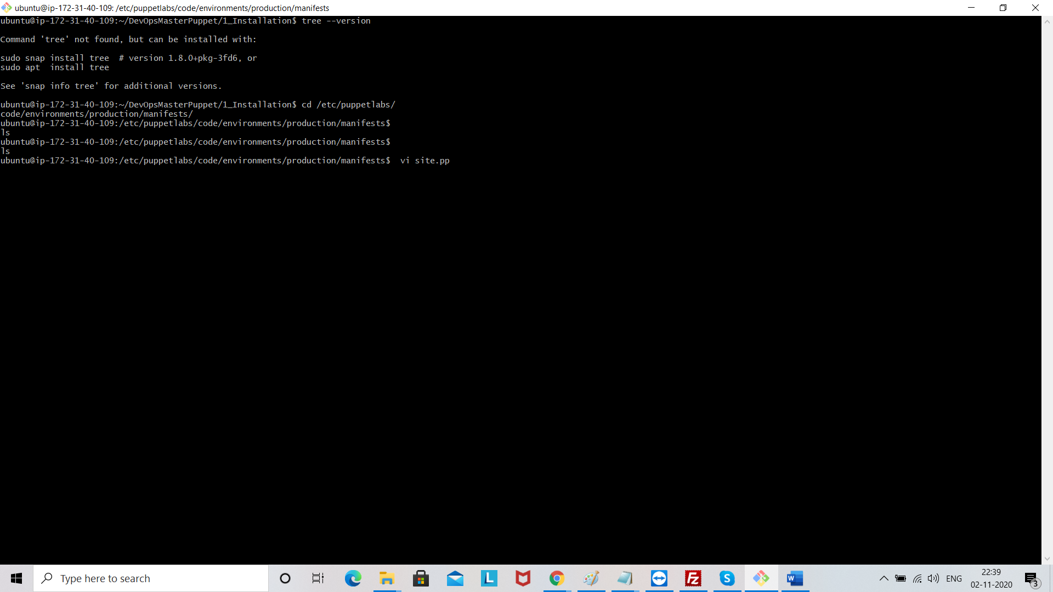

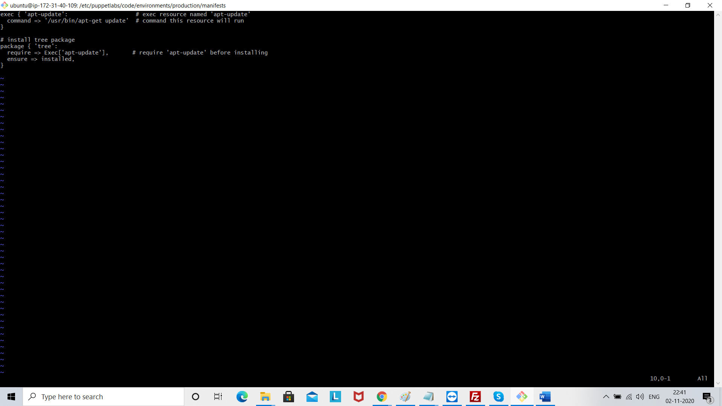

Save the file

!q

